|  |  |  |  |  |  |  |  |  |  |  |  |  |  |  |
| --- | --- | --- | --- | --- | --- | --- | --- | --- | --- | --- | --- | --- | --- | --- |
| |  |  | | --- | --- | | Team name | 6droids | | 14208971 | Tharkana D Kodagoda | | 14208893 | Sahitha Nelanga H De Silva | | 14208910 | H W Srimal Priyanga Fonseka | | 14209059 | Dilina Namal Weerasinghe | | 14209074 | P W Poorni Yasodara | | 14209759 | Kavindu Yudeesha Lakshan Narathota | |

|  |
| --- |
| Assignment – Object Oriented Design (COMP3004L) |
| UML Diagrams for Switch and Rummy card games Final Report |



Contents

**Introduction**

**1.** **User case Diagram**

**2.** **State Diagram**

**3.** **Sequence Diagram**

**4.** **Domain Analysis**

**6.** **Object Diagram**

**7.** **Component Diagram**

**8.** **Deployment Diagram**

**Introduction**

This Report is a collection of UML diagrams which will give a complete example of Object Oriented Analysis, Design and Programming applied to 2 simple card games, Switch and Rummy!

In this case we studied all the possible ways of winning each game and came up with the optimal solution to get the best outcome.

1. **User case Diagram**

C:\Users\Kavindu Narathota\AppData\Local\Microsoft\Windows\INetCache\Content.Word\Usecase Diagram Update - 2.png

Figure 1 - Use Case Diagram

1. **State Diagram**

C:\Users\Kavindu Narathota\AppData\Local\Microsoft\Windows\INetCache\Content.Word\State Diagram - 1.png

Figure 2 - State Diagram



Figure 3 - State Diagram (Rummy)



Figure 4 - State Diagram (Switch)

1. **Sequence Diagram**

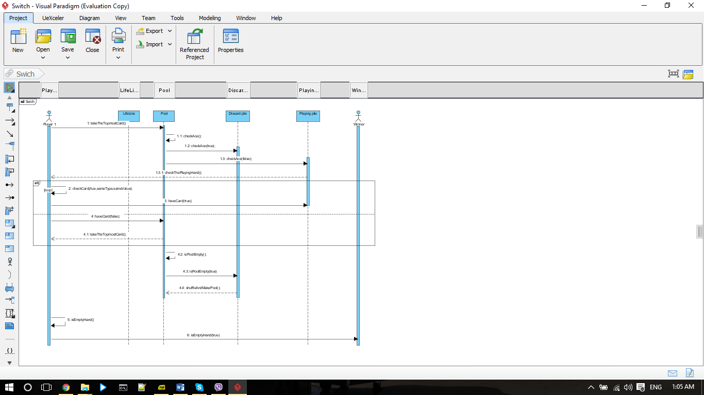

Figure 5 - Sequence Diagram (Switch)

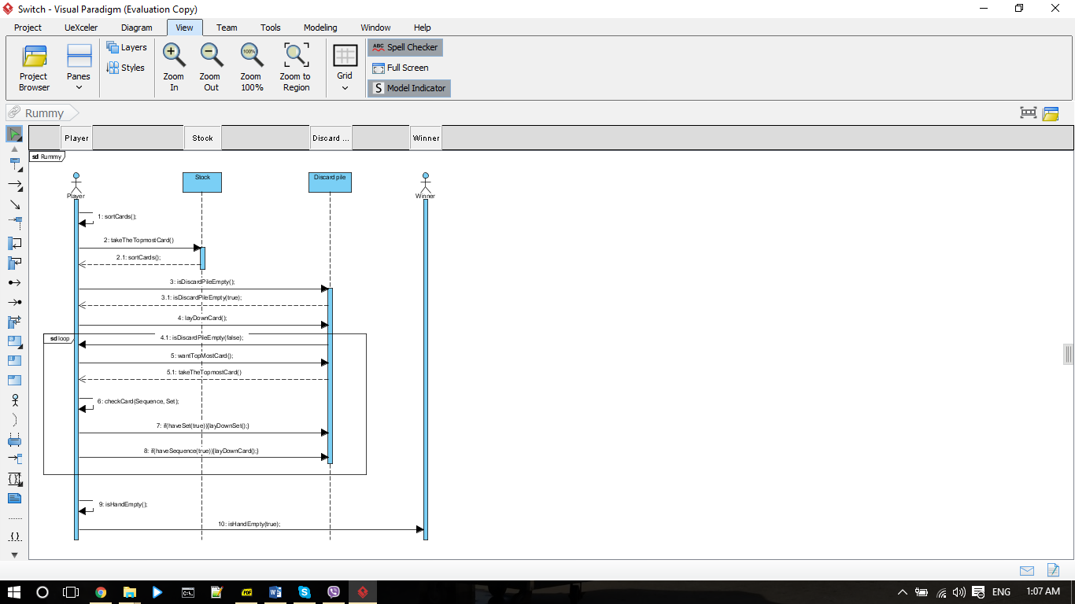

Figure 6 - Sequence Diagram (Rummy)

1. **Domain Analysis**

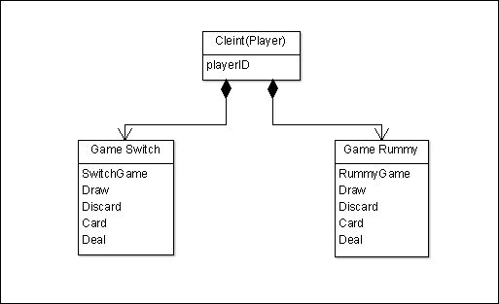

Figure 7 - Domain Analysis

1. **Class Diagram**



Figure 8 - Class Diagram

1. **Object Diagram**



Figure 9 - Object Diagram (Rummy)



Figure 10 - Object Diagram (Switch)

1. **Component Diagram**



Figure 11 - Component Diagram

1. **Deployment Diagram**



Figure 12 - Deployment Diagram